

**SAP Technical Specification**

|  |  |
| --- | --- |
| Project | **Concur Pard/ WBS/CC export-760** |
| Customer | **Serco Group PLC** |
| Solution | **Technical Specification** |
| Version | **0.1** |
| Author | **Naresh Palagiri** |
| Date | **23.08.2022** |

Template Control

| Version | Date | Author | Notes |
| --- | --- | --- | --- |
| 0.1 | 13th August 2013 | Malcolm Smith | Created from existing templates |
| 1.0 | 4th Sept 2013 | John Brinkworth | First Issue |

Document Control

| Version | Date | Author | Notes |
| --- | --- | --- | --- |
| 0.1 | 23rd Aug 2022 | Naresh Palagiri | Initial TS |
| 0.1 |  |  | Reviewed |

Document Location

| Location |
| --- |
| To be uploaded on Ourworld – TBD (Update the link once documents is signed off and uploaded) |

Approval

| Name | Role | Date | Signature |
| --- | --- | --- | --- |
|  |  |  |  |

Distribution

| Name | Role |
| --- | --- |
|  |  |

Table of Contents

1 Overview 4

2 General Information 4

3 Selection Screen 4

4 Database Tables / Structures Used 5

5 Program Details 5

5.1 Solution Details 5

6 Test Evidence 5

7 Annex A – Product Description (reference only) 6

Table of Figures

**No table of figures entries found.**

Table of Tables

**No table of figures entries found.**

# Overview

This interface is to send file from SAP to concur system. New program will be developed to produce file, this file will be used to load delta cost objects(WBS & Cost Center) with previous cost approver into concur.

**Integration/Data Flow Diagram for Statement Employee Extract**

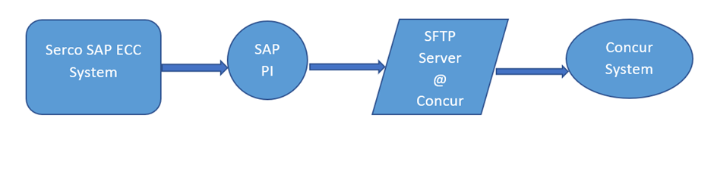

• Job to be scheduled on daily basis before 6 PM UK time will extract WBS and Cost Center data and place the file on AL11.

• Interface will send active WBS/CC of full load files daily and Concur will compare files and update delta changes in Concur.

• SAP PI to poll AL11 folders to pick available files and archive and process to CONCUR with the encrypted format.

# General Information

This will be Outbound interface to Concur system, upload the file in AL11 and SAP PI read the same file and send it to concur system.

Program Z_CONCUR_WBS_CC_PCARD_DELTA

# Selection Screen

There will be options on the selection screen to do a delta load and the file can be downloaded to local machine or application server.

For Delta load.

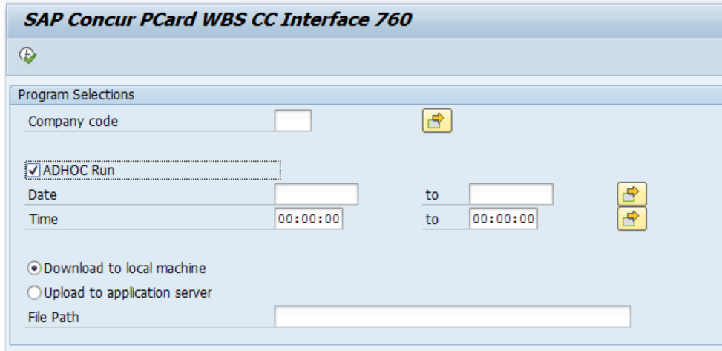

# Database Tables / Structures Used

Tables: ZBURKS_PCARD, CDHDR, CDPOS,

PRPS, JEST, TCJ04, PA0105, ZWBS_CC_TSTAMP.

Function modules : CONVERSION_EXIT_ABPSP_OUTPUT,

/SAPDMC/LSM_F4_SERVER_FILE

ABI_TIMESTAMP_CONVERT_FROM

# Program Details

## Solution Details

**WBS and Cost Center delta changes will fall under the below logic:**

**WBS Delta changes logic:**

1. Go to SE38 and create a new program -

Z_CONCUR_WBS_CC_PCard_DELTA

1. Updating File name, time, date and Timestamp values in “ZWBS_CC_TSTAMP” table.
2. Maintained WBS status in “ZPARAMS” table.
3. Pass OBJECTCLAS= PROJ & UDATE= “Input date” , UTIME = “Input Time” to CDHDR table and get CHANGENR.
4. Pass CDHDR-CHANGENR, TABNAME=PRPS & FNAME=VERNR to CDPOS table and get TABKEY & VALUE_OLD. From TABKEY Separation of MANDT and PSPNR. Pass all PSPNR in conversion FM and get WBS.
5. Person Responsible number (Technical field name= VERNR) from the table PRPS against the WBS element.
6. Pass all WBS to PRPS to get BUKRS. Verify output WBS for custom table ZBUKRS_PCARD. Display in internal table WBS of the VALUE_OLD.
7. Pass CDPOS-VALUE_OLD as PRPS-VERNR to TCJ04 table and get S_USRNAM. Pass TCJ04-S_USRNAM as PA0105-USRID with subtype “0001” to PA0105 table and get PERNR and display this PERNR to output file.
8. Pass the username in table PA0105 for field USRID.
9. This USER ID is the respective employee’s SAP System username and its associated PERNR.
10. Fetch Filepath from custom table ZCONCUR_FL_FORMAT.
11. The structure of the File should contains 13 fields.
12. The PERNR obtained from this table would be updated in (Employee ID) field.
13. The PERNR would be displayed in the Employee ID (Column A) of the extracted file.
14. EP1 and Serco is hard coded in the program for Segment 1 and Segment fields of the extracted file.
15. Fetch PRCTR from table PRPS and Company code fields data and displayed in Segment 3 and Segment 4 respectively.
16. Once file is ready, need to write code for download and transfer file to the path specified by the user.
17. Once file is ready need to store it in AL11 folder by using OPEN DATASET, TRANSFER AND CLOSE DATASET.
18. Store the timestamp in ztable: ZCONCUR_FL_FORMAT, during next run use timestamp of last run and execute above steps to show details in 760 file.

**Cost Center delta changes** **logic**:

In the same Program : Z_CONCUR_WBS_CC_PCard_DELTA

1. Validate the company code list data from the custom table “ZBUKRS_PCARD”.
2. Analysis period (End date of Cost center) should be 31.12.9999, refer the table “CSKS” and the field DATBI.
3. Actual Primary cost and Actual Secondary cost is not equal to “X” refer the table “CSKS” and the fields BKZKS and BKZKP.
4. Pass the OBJECTCLAS - KOSTL in CDHDR table and pick the CHANGENR (document number) and OBJECTID = Object value-100001000000102 (First 4 characters should be a Controlling area and last 9 digit should be Cost center characters.
5. Pass the CHANGENR (document number) in CDPOS table and check the for the field VERAK (Person responsible) and pick the VALUE_OLD (latest Old personal responsible) value.
6. The structure of the File should contains 13 fields.
7. Once file is ready, need to write code for download and transfer file to the path specified by the user.
8. This file needs to store in AL11 folder by using OPEN DATASET, TRANSFER AND CLOSE DATASET.
9. Store the timestamp in ztable : ZCONCUR_FL_FORMAT, during next run use timestamp of last run and execute above steps to show details in 760 file.

**Cutover activities:**

1. Maintain Filepath details in all the systems in the table “ZCONCUR_FL_FORMT”.

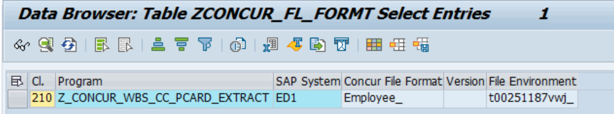

1. Maintain WBS status in ZPARAMS table.

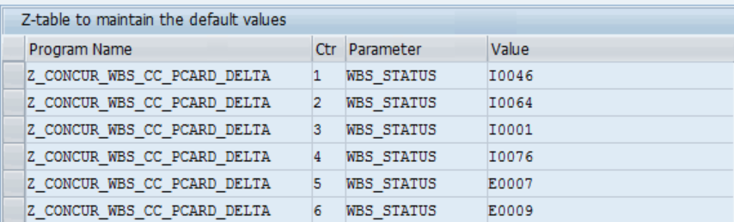

# Test Evidence



# Annex A – Product Description (reference only)

For reference purposes only – Delete if required

|  |  |
| --- | --- |
| **Product Description** | |
| **What?** | The SAP Technical Specification is a detailed description of the technical development required to meet the needs identified in the related Functional Specification. |
| **Why?** | The benefits of completing a SAP Technical Specification are:   * To provide a clear documentation of what has been developed in the system, and why. * To help future support and maintenance of the system. |
| **Who?** | The Developer is responsible for:   * Documenting the technical development requirements.   The Project Manager is responsible for:   * Ensuring that a Technical Specification document is completed for each development. |
| **When?** | The Technical Specification should be completed in the Design Stage:  Dependencies:  The Technical Specification should be delivered with the following considerations:   * Design of the Functional Specification. |
| **Hints and Tips** | N/A |
| **Next Steps** | Once completed you should consider the following products or actions:   * Testing |